The Calculator

* Write a function called squareNumber that will take one argument (a number), square that number, and return the result. It should also log a string like "The result of squaring the number 3 is 9."

function squareNumber(num) {

let result = num * num;

console.log(`The result of squaring the number ${num} is ${result}.`);

return result;

}

* Write a function called halfNumber that will take one argument (a number), divide it by 2, and return the result. It should also log a string like "Half of 5 is 2.5.".

function halfNumber(num) {

let result = num / 2;

console.log(`Half of ${num} is ${result}.`);

return result;

}

* Write a function called percentOf that will take two numbers, figure out what percent the first number represents of the second number, and return the result. It should also log a string like "2 is 50% of 4."

function percentOf(num1, num2) {

let result = (num1 / num2) * 100;

console.log(`${num1} is ${result}% of ${num2}.`);

return result;

}

* Write a function called areaOfCircle that will take one argument (the radius), calculate the area based on that, and return the result. It should also log a string like "The area for a circle with radius 2 is 12.566370614359172."
  + Bonus: Round the result so there are only two digits after the decimal.

function areaOfCircle(radius) {

let area = Math.PI * radius * radius;

let rounded = parseFloat(area.toFixed(2));

console.log(`The area for a circle with radius ${radius} is ${rounded}.`);

return rounded;

}

* Write a function that will take one argument (a number) and perform the following operations, using the functions you wrote earlier1:
  + Take half of the number and store the result.
  + Square the result of #1 and store that result.
  + Calculate the area of a circle with the result of #2 as the radius.
  + Calculate what percentage that area is of the squared result (#3).

function doCalculations(num) {

let half = halfNumber(num);

let squared = squareNumber(half);

let area = areaOfCircle(squared);

let percent = percentOf(area, squared);

return percent;

}

doCalculations(4);

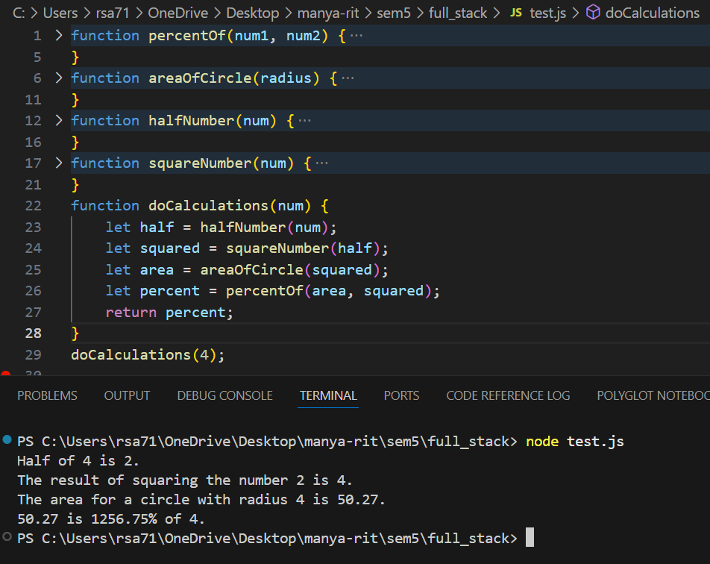

MixUp

* Create a function called mixUp. It should take in two strings, and return the concatenation of the two strings (separated by a space) slicing out and swapping the first 2 characters of each. You can assume that the strings are at least 2 characters long. For example:
* mixUp('mix', pod'): 'pox mid'
* mixUp('dog', 'dinner'): 'dig donner'

function mixUp(str1, str2) {

let newStr1 = str2.slice(0, 2) + str1.slice(2);

let newStr2 = str1.slice(0, 2) + str2.slice(2);

return newStr1 + ' ' + newStr2;

}

console.log(mixUp('mix', 'pod'));

console.log(mixUp('dog', 'dinner'));

FixStart

* Create a function called fixStart. It should take a single argument, a string, and return a version where all occurences of its first character have been replaced with '*', except for the first character itself. You can assume that the string is at least one character long. For example:
* fixStart('babble'): 'ba**le'

function fixStart(str) {

let firstChar = str[0];

let rest = str.slice(1).replace(new RegExp(firstChar, 'g'), '*');

return firstChar + rest;

}

console.log(fixStart('babble'));

### Verbing

* Create a function called verbing. It should take a single argument, a string. If its length is at least 3, it should add 'ing' to its end, unless it already ends in 'ing', in which case it should add 'ly' instead. If the string length is less than 3, it should leave it unchanged. For example:
* verbing('swim'): 'swimming'
* verbing('swimming'): 'swimmingly'
* verbing('go'): 'go'

function verbing(str) {

if (str.length >= 3) {

if (str.endsWith('ing')) {

return str + 'ly';

} else {

return str + 'ing';

}

} else {

return str;

}

}

console.log(verbing('swim'));

console.log(verbing('swimming'));

console.log(verbing('go'));

### Not Bad

* Create a function called notBad that takes a single argument, a string.
* It should find the first appearance of the substring 'not' and 'bad'.
* If the 'bad' follows the 'not', then it should replace the whole 'not'...'bad' substring with 'good' and return the result.
* If it doesn't find 'not' and 'bad' in the right sequence (or at all), just return the original sentence.

For example:

* notBad('This dinner is not that bad!'): 'This dinner is good!'
* notBad('This movie is not so bad!'): 'This movie is good!'
* notBad('This dinner is bad!'): 'This dinner is bad!'

function notBad(str) {

let notIndex = str.indexOf('not');

let badIndex = str.indexOf('bad');

if (notIndex !== -1 && badIndex !== -1 && badIndex > notIndex) {

return str.slice(0, notIndex) + 'good' + str.slice(badIndex + 3);

} else {

return str;

}

}

console.log(notBad('This dinner is not that bad!'));

console.log(notBad('This movie is not so bad!'));

console.log(notBad('This dinner is bad!'));

### The Pluralizer

* Write a function named pluralize that:
  + takes 2 arguments, a noun and a number.
  + returns the number and pluralized form, like "5 cats" or "1 dog".
* Call that function for a few different scores and log the result to make sure it works.
* Bonus: Make it handle a few collective nouns like "sheep" and "geese".

function pluralize(noun, number) {

let irregulars = {sheep: 'sheep', goose: 'geese'};

let plural = irregulars[noun] || noun + 's';

if (number === 1) {

return number + ' ' + noun;

} else {

return number + ' ' + plural;

}

}

console.log(pluralize('cat', 5));

console.log(pluralize('dog', 1));

console.log(pluralize('sheep', 3));

console.log(pluralize('goose', 2));

console.log(pluralize('fish', 4));

### The Array

* Create an array to hold your top choices (colors, presidents, whatever).
* For each choice, log to the screen a string like: "My #1 choice is blue."
* **Bonus:** Change it to log "My 1st choice, "My 2nd choice", "My 3rd choice", picking the right suffix for the number based on what it is.

let choices = ['blue', 'green', 'red', 'yellow', 'purple'];

for (let i = 0; i < choices.length; i++) {

let suffix = 'th';

if (i === 0) suffix = 'st';

else if (i === 1) suffix = 'nd';

else if (i === 2) suffix = 'rd';

console.log(`My ${i + 1}${suffix} choice is ${choices[i]}.`);

}

### Simple word guessing game

You'll create a simple word guessing game where the user gets infinite tries to guess the word (like Hangman without the hangman, or like Wheel of Fortune without the wheel and fortune).

* Create two global arrays: one to hold the letters of the word (e.g. 'F', 'O', 'X'), and one to hold the current guessed letters (e.g. it would start with '_', '_', '_' and end with 'F', 'O', 'X').
* Write a function called guessLetter that will:
  + Take one argument, the guessed letter.
  + Iterate through the word letters and see if the guessed letter is in there.
  + If the guessed letter matches a word letter, changed the guessed letters array to reflect that.
  + When it's done iterating, it should log the current guessed letters ('F__')
  + and congratulate the user if they found a new letter.
  + It should also figure out if there are any more letters that need to be guessed,
  + and if not, it should congratulate the user for winning the game.
* Pretend you don't know the word, and call guessLetter multiple times with various letters to check that your program works.
* **Bonus:** Make it more like Wheel of Fortune:
  + Start with a reward amount of $0
  + Every time a letter is guessed, generate a random amount and reward the user if they found a letter (multiplying the reward if multiple letters found), otherwise subtract from their reward.
  + When they guess the word, log their final reward amount.
* **Bonus:** Make it like Hangman:
  + Keep track of all the guessed letters (right and wrong) and only let the user guess a letter once. If they guess a letter twice, do nothing.
  + Keep track of the state of the hangman as a number (starting at 0), and subtract or add to that number every time they make a wrong guess.
  + Once the number reaches 6 (a reasonable number of body parts for a hangman), inform the user that they lost and show a hangman on the log.

let wordLetters = ['F', 'O', 'X'];

let guessedLetters = ['_', '_', '_'];

let guessedSet = new Set();

let reward = 0;

let hangmanState = 0;

function guessLetter(letter) {

letter = letter.toUpperCase();

if (guessedSet.has(letter)) return;

guessedSet.add(letter);

let found = false;

let count = 0;

for (let i = 0; i < wordLetters.length; i++) {

if (wordLetters[i] === letter && guessedLetters[i] === '_') {

guessedLetters[i] = letter;

found = true;

count++;

}

}

console.log(guessedLetters.join(''));

if (found) {

console.log(`Good job! You found ${count} letter(s).`);

reward += count * Math.floor(Math.random() * 100 + 1);

} else {

console.log(`Sorry, ${letter} is not in the word.`);

reward -= Math.floor(Math.random() * 50 + 1);

hangmanState++;

if (hangmanState >= 6) {

console.log('Game over! The hangman is complete.');

return;

}

}

if (!guessedLetters.includes('_')) {

console.log(`Congratulations! You guessed the word. Your reward is $${reward}.`);

}

}

guessLetter('f');

guessLetter('o');

guessLetter('x');

guessLetter('a');

guessLetter('f');

### The Recipe Card

Never forget another recipe!

* Create an object to hold information on your favorite recipe. It should have properties for title (a string), servings (a number), and ingredients (an array of strings).
* On separate lines (one console.log statement for each), log the recipe information so it looks like:
* Mole
* Serves: 2
* Ingredients:
* cinnamon
* cumin
* cocoa

let recipe = {

title: 'Mole',

servings: 2,

ingredients: ['cinnamon', 'cumin', 'cocoa']

};

console.log(recipe.title);

console.log('Serves: ' + recipe.servings);

console.log('Ingredients:');

for (let ingredient of recipe.ingredients) {

console.log(ingredient);

}

### The Reading List

Keep track of which books you read and which books you want to read!

* Create an array of objects, where each object describes a book and has properties for the title (a string), author (a string), and alreadyRead (a boolean indicating if you read it yet).
* Iterate through the array of books. For each book, log the book title and book author like so: "The Hobbit by J.R.R. Tolkien".
* Now use an if/else statement to change the output depending on whether you read it yet or not. If you read it, log a string like 'You already read "The Hobbit" by J.R.R. Tolkien', and if not, log a string like 'You still need to read "The Lord of the Rings" by J.R.R. Tolkien.'

let books = [

{title: 'The Hobbit', author: 'J.R.R. Tolkien', alreadyRead: true},

{title: 'The Lord of the Rings', author: 'J.R.R. Tolkien', alreadyRead: false},

{title: '1984', author: 'George Orwell', alreadyRead: true}

];

for (let book of books) {

if (book.alreadyRead) {

console.log(`You already read "${book.title}" by ${book.author}`);

} else {

console.log(`You still need to read "${book.title}" by ${book.author}`);

}

}

## Exercises: Objects as Arguments

### The Movie Database

It's like IMDB, but much much smaller!

* Create an object to store the following information about your favorite movie: title (a string), duration (a number), and stars (an array of strings).
* Create a function to print out the movie information like so: "Puff the Magic Dragon lasts for 30 minutes. Stars: Puff, Jackie, Living Sneezes."

let movie = {

title: 'Puff the Magic Dragon',

duration: 30,

stars: ['Puff', 'Jackie', 'Living Sneezes']

};

function printMovieInfo(movie) {

console.log(`${movie.title} lasts for ${movie.duration} minutes. Stars: ${movie.stars.join(', ')}.`);

}

printMovieInfo(movie);

### The Cash Register

* Write a function called cashRegister that takes a shopping cart object. The object contains item names and prices (itemName: itemPrice). The function should return the total price of the shopping cart.
* Example
* // Input
* var cartForParty = {
* banana: "1.25",
* handkerchief: ".99",
* Tshirt: "25.01",
* apple: "0.60",
* nalgene: "10.34",
* proteinShake: "22.36"
* };
* // Output
* cashRegister(cartForParty)); // 60.55

function cashRegister(cart) {

let total = 0;

for (let item in cart) {

total += parseFloat(cart[item]);

}

return total;

}

let cartForParty = {

banana: "1.25",

handkerchief: ".99",

Tshirt: "25.01",

apple: "0.60",

nalgene: "10.34",

proteinShake: "22.36"

};

console.log(cashRegister(cartForParty));

# Credit Card Validation

You're starting your own credit card business. You've come up with a new way to validate credit cards with a simple function called validateCreditCard that returns true or false.

Here are the rules for a valid number:

* Number must be 16 digits, all of them must be numbers
* You must have at least two different digits represented (all of the digits cannot be the same)
* The final digit must be even
* The sum of all the digits must be greater than 16

The following credit card numbers are valid:

* 9999-9999-8888-0000
* 6666-6666-6666-1666

The following credit card numbers are invalid:

* a923-3211-9c01-1112 invalid characters
* 4444-4444-4444-4444 only one type of number
* 1111-1111-1111-1110 sum less than 16
* 6666-6666-6666-6661 odd final number

**Bonus:** Return an object indicating whether the credit card is valid, and if not, what the error is   
{ valid: true, number: 'a923-3211-9c01-1112' }   
{ valid: false, number: 'a923-3211-9c01-1112', error: ‘wrong_length’ }

function validateCreditCard(cardNumber) {

let cleanNumber = cardNumber.replace(/-/g, '');

if (!/^\d+$/.test(cleanNumber)) return { valid: false, number: cardNumber, error: 'invalid_characters' };

if (cleanNumber.length !== 16) return { valid: false, number: cardNumber, error: 'wrong_length' };

let digits = cleanNumber.split('').map(Number);

let uniqueDigits = new Set(digits);

if (uniqueDigits.size < 2) return { valid: false, number: cardNumber, error: 'only_one_type_of_number' };

if (digits[digits.length - 1] % 2 !== 0) return { valid: false, number: cardNumber, error: 'odd_final_number' };

let sum = digits.reduce((a, b) => a + b, 0);

if (sum <= 16) return { valid: false, number: cardNumber, error: 'sum_less_than_16' };

return { valid: true, number: cardNumber };

}

console.log(validateCreditCard('9999-9999-8888-0000'));

console.log(validateCreditCard('6666-6666-6666-1666'));

console.log(validateCreditCard('a923-3211-9c01-1112'));

console.log(validateCreditCard('4444-4444-4444-4444'));

console.log(validateCreditCard('1111-1111-1111-1110'));

console.log(validateCreditCard('6666-6666-6666-6661'));

